Chapter 19, Problem 37.

The input port of the circuit in Fig.19.79 is connected to a 10-V dc voltage source while the output port is terminated by a 5-Ω resistor. Find the voltage across the 5-Ω resistor by using h parameters of the circuit. Confirm your result by using direct circuit analysis.

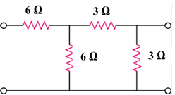

Figure 19.79
For Probs. 19.18 and 19.37.

